**Design spectra:**

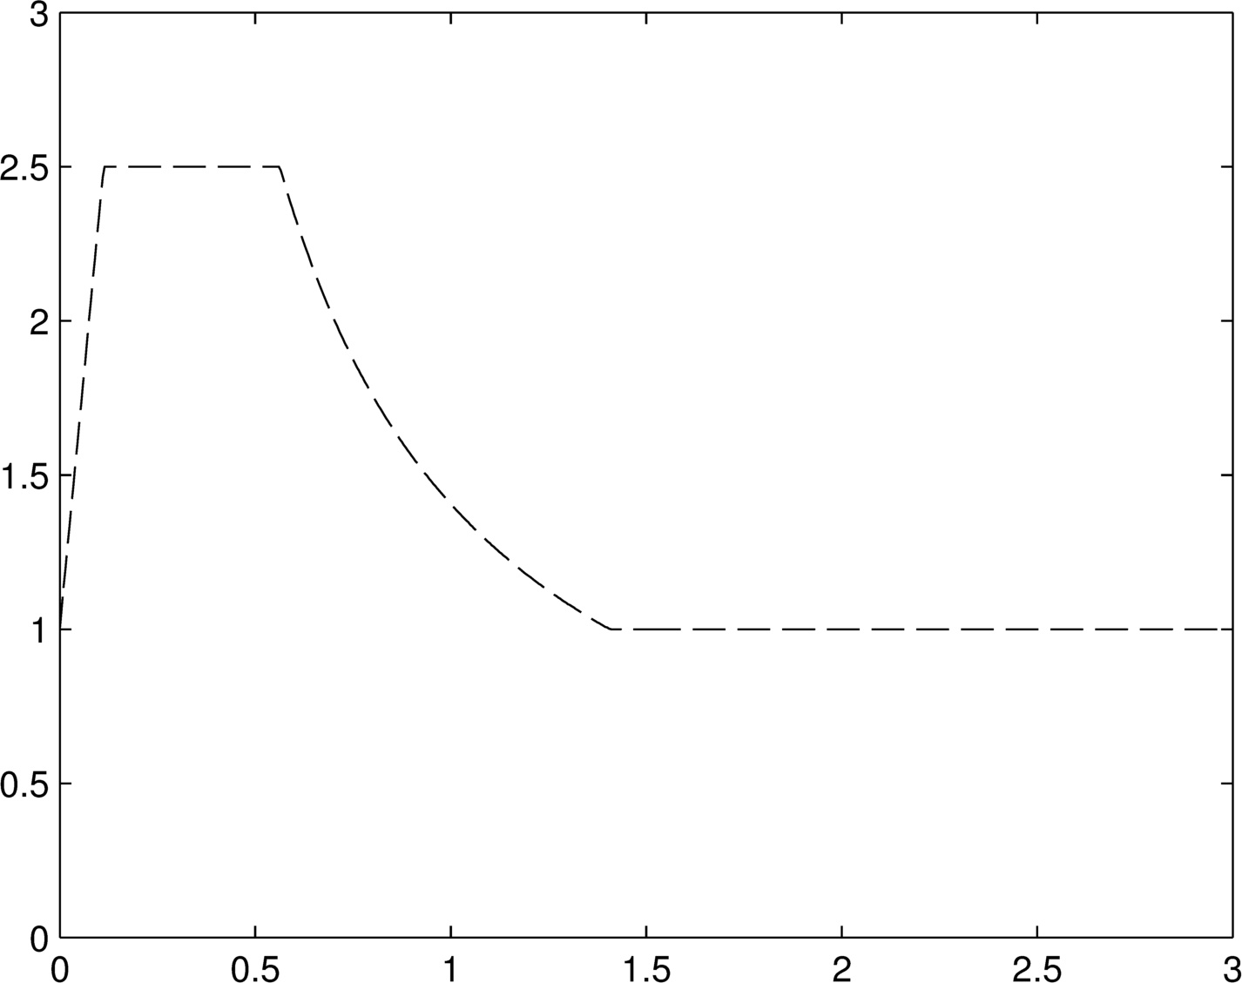

isolated

Non-isolated

**Association with response spectrum:**

1. 消能元件:利用結構或裝置的良好塑性行為形成飽滿的遲滯曲線,進而消散外界輸入之能量.
2. 隔震系統:提供一個柔性並具消能能力之隔震系統,使其在地震力下,上部結構呈剛體運動,使其損壞率下降.其原理為延長結構週期,以減少地震力輸入.
3. 低矮的建築較適合用隔震來減低上部結構的需求,較高的結構因其本身周期較長故不適合.

**Damping reduction factor:**

1. 
2. Use B factor to consider the damping effect on base shear.
3. Current code allow to use Bmin=0.75.
4. Along period increase, the effect that adding damping to reduce disp. and vel. will not very significant. Acceleration is contrary.
5. It may not be conservative to use the same B value regardless of periods.

**Damper overview:**

**Displacement dependent:**

Bending type: triangle plate設計參數: 抗彎構架側向勁度,高度寬厚比,SHRa, SHRd

Shear type:: panel

Axial type:: BRB設計參數:抗彎構架側向勁度

Add stiffness, after yielding add damping. Disp. and vel. will reduce but accel. may not.

**Velocity dependent:**

VE:剪力變形消能. 設計參數:結構頻率,環境溫度,剪應變,材料溫度

VD:阻尼動能轉換熱能. 設計參數:結構頻率,阻尼冪次,阻尼元件阻尼比

**VE damper:**

**Feature:**

1. 小變形時,比起震幅大小.環境溫度跟振動頻率對VE damper有更大的影響
2. 相同剪應變下,環境溫度的上升會減低VE damper的勁度.
3. 相同環境溫度下, 剪應變的上升會減低VE damper的勁度.
4. 隨著震動的次數跟幅度增加,會提高VE damper的溫度而減低VE damper的勁度.但這影響會隨著震動的次數增加而下降.
5. Shear deformation in VE material.
6. Dissipate energy though heat.
7. Adding damping and stiffness.
8. Additional damping provide as soon as structure vibrate.

**Material property:**

 





**Calculate equivalent damping ratio:**

1. Modal strain energy method: predict 



1. Damping coefficient method: get



1. Half-power method: get 



**VE damper design procedure:**

1. Seek  first.
2. Use modal strain energy method to get 
3. Trial and error

**VD damper:**

**Feature:**

1. 和速度同向,位移反向(差90度)
2. 在特定頻率(f<4Hz)內沒有儲存勁度
3. Not very significant affected by temperature.
4. 速度較小時,非線性阻尼器可以提供較大之阻尼力. 但速度較大時增加的力量就有限.一般用非線性阻尼器較經濟.
5. 不具有儲存勁度,不影響結構週期,設計起來較為方便

**Material property:**



Linear:

 For each damper is same.

Nonlinear:

 



**VE damper design procedure:**

1. Seek　、、(for nonlinear also need A)
2. Use formula to decide C value.
3. Assign in model

**Seismic isolation:**

**Basic requirements:**

1. 足以承受垂直向載重(勁度及強度)
2. 在大地震下,有足夠的柔度可以延長結構物側向勁度
3. 可以承受額外阻尼來降低位移需求
4. 隔震層要有一定的勁度以抵抗風力
5. 隔震層要有能力復位
6. 可以提供第二防禦措施

**Feature:**

1. The effect of substructure is really important in particular when substructure possesses a smaller stiffness and a larger mass.
2. The design of substructure and superstructure with higher vibration frequencies exhibits a better seismic performance.
3. The participation of the modal responses of the higher modes should be taken into account for the design of substructure.
4. The responses at isolation layer and superstructure are significantly enlarged within the certain frequency ratio bandwidth due to the modal coupling effect.
5. Nonlinear response history analyses are needed for mid-story isolation designs.

**Type:**

**NRB:**

The bearing consists of two thick plates on the top and bottom to connect the bearing and the structure. Rubber layers with low shear modulus provide lateral flexibility. Shim steel plates are used between the rubber layers to prevent from lateral bulge and increase vertical stiffness and load capacity. In general, the lateral surface of bearing is covered by a thin layer of rubber to protect from UV light and Oxidation.

**Advantage**: easy and economical to make.

**Disadvantage**: low damping, need to provide extra damping.**LRB:**

The structure of LRB is similar to that of NRB except the addition of lead plugs at the center core. The shim plates and rubber layers confine the lead plug to develop stable shear hysteresis behavior under lateral deformation which provides additional damping. LRB was invented by Bill Robinson in New Zealand in 1970 and becomes the most widely used seismic isolation device.**HDRB:**

HDRB was invented in England in 1982 by adding materials such as fine carbon powder, oil, resin and other additives to increase damping of rubber. HRB provides high damping and stiffness at large shear strain. Even under low strain conditions, HRB also provide significant and lateral stiffness and may filter out vibration noises resulted from traffic.

**FPS:**

FPS combines sliding and re-centering mechanism, composes of a articulated slider on a stainless steel ball surface. The contact between the slider and ball surface is coated with low friction, low wear and auto lubricates composite material.**Roller-Type Bearing**

**Formula:**

**Rubber bearing:**

  

load area/free area (unfilled hole)

tr: Total rubber thickness.

**LRB Model:**

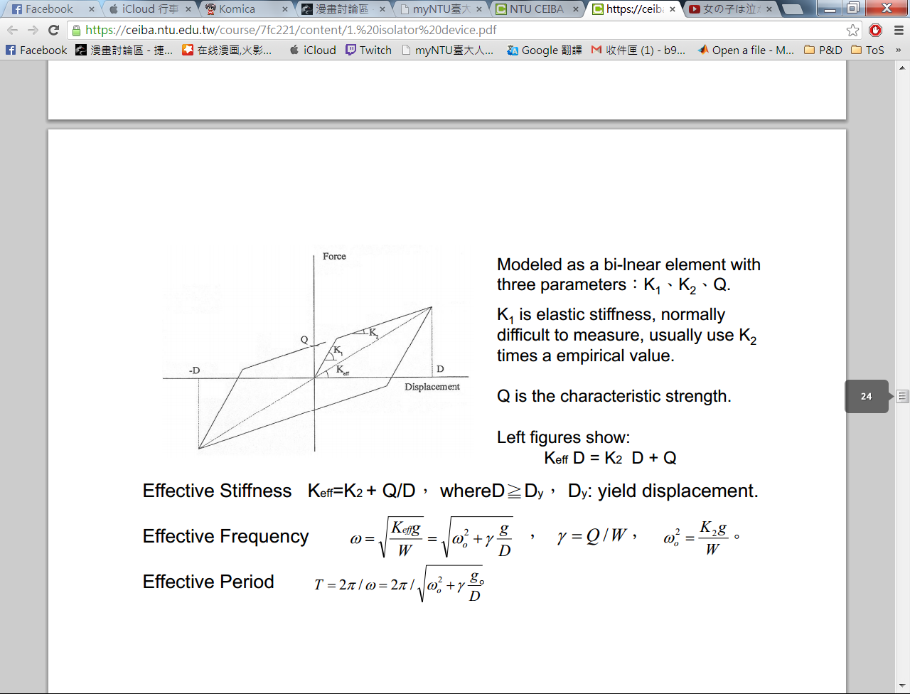

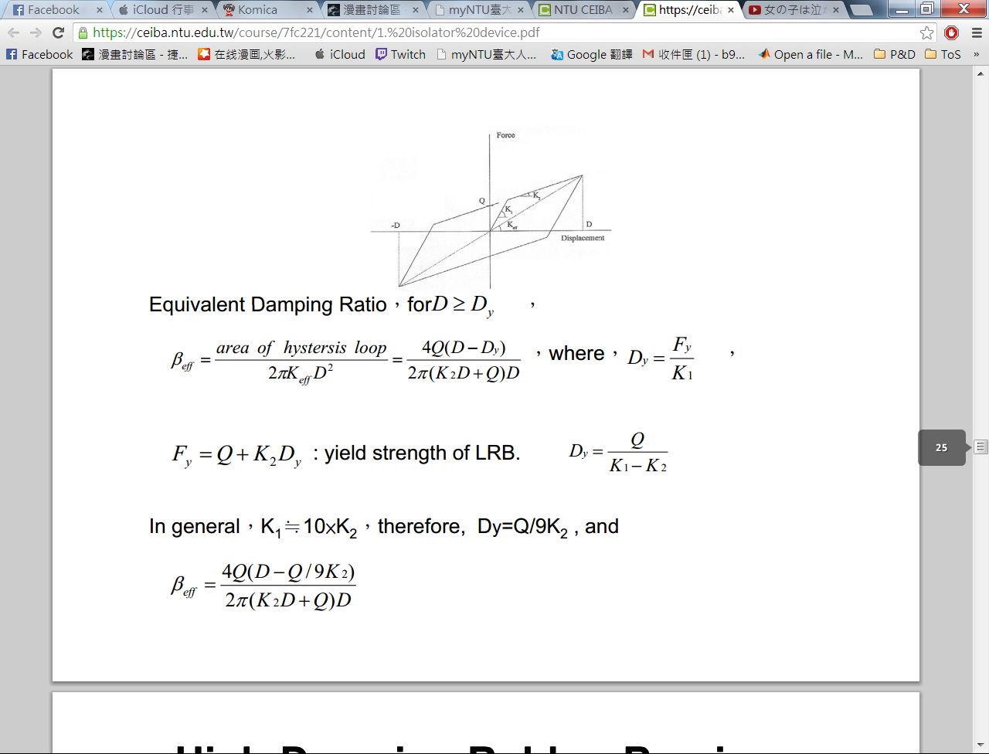

**Isolation design procedure:**

Disp. based design

Iteration general procedure(、、、)

1. Determine design disp.
2. Determine design force (、)

Try bearing properties (use vender’s information)

1. Design the structure
2. Analysis and check drift, bearing pressure, bearing deformation.

**LRB detail:**

1. 分析得、、、 、、 、 、
2. 決定支承墊設計應變:50%及設計溫度:28
3. 由以上資料求得有效剪力模數Ｇ,EB=500
4. 計算支承墊總厚度,
5. 設計鉛心，由支承墊特性強度及鉛心降伏應力求得

設

1. 計算支承墊段面積Ａ和斷面尺寸

* 利用承受之容許壓力計算面積



 

* 利用載重估算面積

選擇S

 



* 利用支承剪力計算面積

 

* 選擇最大斷面以及決定斷面尺寸



1. 求得單層橡膠厚度(ti)及橡膠層數(N)

. 圓形襯墊: d for diameter

 再修正

1. 設計鋼板厚度(ts)



1. 計算整體高度

設上下鋼板2.5cm



1. 剪應變和穩定度檢核

* 受垂直載重時之剪應變



* 考慮地震力的載重組合

 Avoid roll-out

 穩定度要求



* 鉛心尺寸

